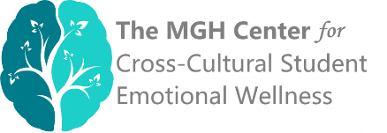

MGH Center for Cross-Cultural Student Emotional Wellness (CCCSEW) Consortium

Application for Academic Year 2021-2022

Name of school:

Name and title of primary representative (i.e., the point person for MGH):

Email: Telephone:

Mailing address:

_____________________________________________________________________________
Total number of students on campus (approx.):
Total number of international students on campus (approx.):

Other diversity statistics: Please include other available relevant information below (e.g., about racial / ethnic diversity, socioeconomic diversity)

How did you hear about the Consortium?

What would be the biggest goal of joining the Consortium for your school?

_____________________________________________________________________________
Please list up to four additional Consortium representatives for your school.

Name and title of representative #2:
Email:

Name and title of representative #3:
Email:

Name and title of representative #4:
Email:

Name and title of representative #5:
Email:

Please email your completed application to: info@mghstudentwellness.org.

